E
 | 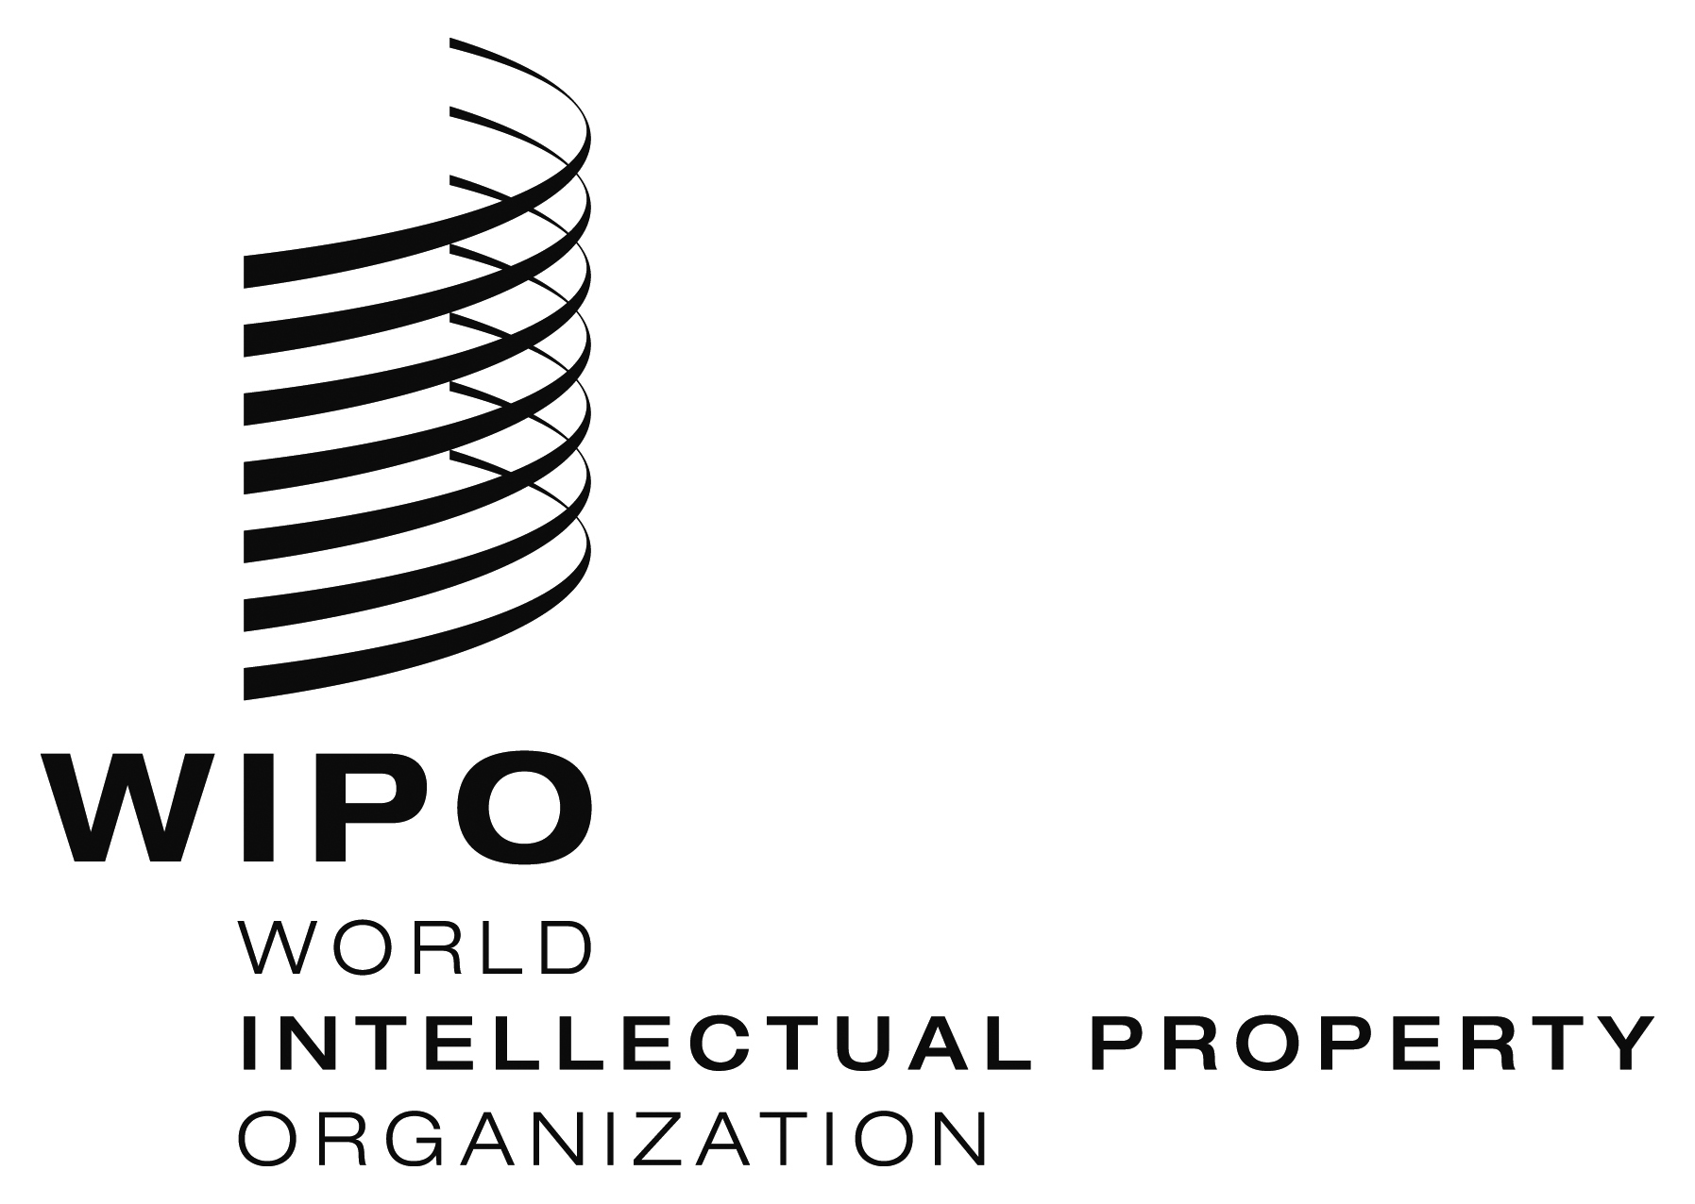
Regional Meeting
WIPO/IPR/ /14/inf/1 Prov
ORIGINAL: english
DATE: july 2014

Recent Intellectual Property Challenges

organized by
the World Intellectual Property Organization (WIPO)

in cooperation with
the Industrial Property Office of the Slovak Republic (IPOSR)

Banská Bystrica, October 28 to 29, 2014

Provisional Program

prepared by the International Bureau of WIPO

Wednesday, October 28, 2014

9.00 – 9.30 Registration

9.30 – 9.45 OPENING CEREMONY

Welcome addresses by:
- Mr. Peter Gogola, Mayor of Banská Bystrica
- Mr. Ľuboš Knoth, President, Industrial Property Office of the Slovak Republic (IPOSR), Banská Bystrica
- Mr. Michal Svantner, Director, Department for Transition and Developed Countries (TDC), World Intellectual Property Organization (WIPO), Geneva

9.45 – 10.30 Topic 1 Intellectual Property (IP) Challenges in the Region and Support for Innovation, Entrepreneurship and SMSs

Speaker: Mr. Michal Svantner, Director, Department for
Transition and Developed Countries (TDC), World
Intellectual Property

10.30 – 11.15 Topic 2 Recent Developments with Respect to the Economic Aspects of Intellectual Property Rights (IPRs)

Speaker: Mr. Peter Kaldos, Economist, HIPAVILON Hungarian Intellectual Property Agency, Budapest

11.15 – 11.30 Coffee Break

11.30 – 12.15 p.m. Topic 3 Current Economic Aspects of IP in Slovakia from the IPO SR perspective

Speaker: Mr. Ľuboš Knoth, President, Industrial Property Office of the Slovak Republic (IPOSR), Banská Bystrica

12.15 p.m. – 2.00 p.m. Lunch Break

2.00 p.m. – 3.00 p.m. Topic 4 Current Practices and Experiences of IP in Slovakia related to Economic Issues of IP

Moderator: Mrs. Lucia Lalíková, Officer in Charge, IPO SR

Speaker: Mr. Peter Kardoš, Faculty of Business Management, Economical University Bratislava
IP Evaluation and IP License Agreement

3.00 p.m. – 3.30 p.m. Coffee Break

3.30 p.m. – 5.00 p.m. Topic 4 Current Practices and Experiences of IP in Slovakia related to Economic Issues of IP

Moderator: Mrs. Lucia Lalíková, Officer in Charge, IPO SR

Speakers: Invited local speaker (tbc)
Mr. Miroslav Kubiš, Head of Technology Transfer Dept., Slovak Centre of Scientific and Technical Information

Support of Establishment and Development of Slovak Business Agency (SBA) – (Phase 1)

5.15 p.m. – 5.30 p.m. Q&A

Thursday, October 29, 2014

9.00 – 9.45 Topic 5 Best Practices in the Use of IP by SMSs for Regional Economic Development and Innovation

Speaker: Mr. Peter Kaldos, Economist, HIPAVILON Hungarian Intellectual Property Agency, Budapest

9.45 – 10.30 Topic 6 Strategic Use of IPRs for Business Development

Speaker: Invited local speaker (tbc)

10.30 – 11.00 Coffee Break

11.00 – 11.45 Topic 7 Roundtable Discussion – Current Practices and Experiences in the Region related to Economic Issues of IPRs

Moderator: Ms. Lucia Lalíková, Senior Officer, IPO SR

Speakers: Invited Regional Participants

11.45– 12.00 p.m. CLOSING CEREMONY

Speakers: Mr. Ľuboš Knoth

Mr. Michal Svantner

[End of document]

